

User Manual

V1.0

Contents

Introduction 2

Functionalities 3

Front End 3

Navbar 3

Site User Registration 3

Home Page 5

Posts Page 6

Industry Partners Page 6

Contact Us Page 7

About Page 8

Back End 8

Navbar 8

Dashboard Page 8

Industry Partners Page 9

Internship Program Page 9

Site Users Page 9

# Introduction

The Industry-Academe Cooperative Education Program, also known as the I-ACE Program, is an internship program of the Asia Pacific College, where students on their senior year are assigned to work full time for a company for a period of two consecutive terms.  
The objective of the program is to link industry and academe. This program is envisioned to be a good venue to expose the school to the relevant and changing needs of the industry. The industry sector, on the other hand, absorbs the intern and is encouraged to be involved in the education and development of future Information Technology and Business professionals from their respective courses and specializations.  
On their senior year, APC students enter the Industry-Academe Cooperative Education Program. They are assigned to work for a pre-identified company (assigned during the internship placement period), for a duration of two (2) consecutive terms of APC’s trimestral school calendar.  
  
During the Internship Program, the Interns are not expected to enroll in any academic courses in school for they will be working full-time (eight hours a day, Mondays to Fridays) at their respective companies. Interns are invited to attend once a month Saturday sessions with the Career & Placement Office to discuss updates, issues or problems encountered.  
  
As interns, they are expected to strictly follow office policies of the company they work for and abide by the principle of confidentiality with regard to any information / restricted materials on their assigned projects.

The system will include a dashboard in which CPO can post updates and/or announcements. The dashboard is only accessible by the CPO. The system will also cater the communication between the CPO and the industry partner’s HR for faster response in each requests.

# Functionalities

The APC Career Placement Office is divided into two, the administration part is the backend and the more visible one is the frontend.

## Frontend

### Navbar

The Navbar or Navigation bar is the part of the system where quick links are accessible.



Figure : Navigation Bar

### Site User Registration

This module is used by guest users for them to have user account to the system. There will be four (4) types of users in the system and there will be only three (3) available for registration.

#### Signup and Login Button

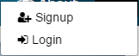

Figure : Signup and Login buttons

The signup and login buttons are located on the right side of the Navbar after clicking the arrow down button.

#### Signup form

The signup form gathers all the basic information from the users for use in the system.

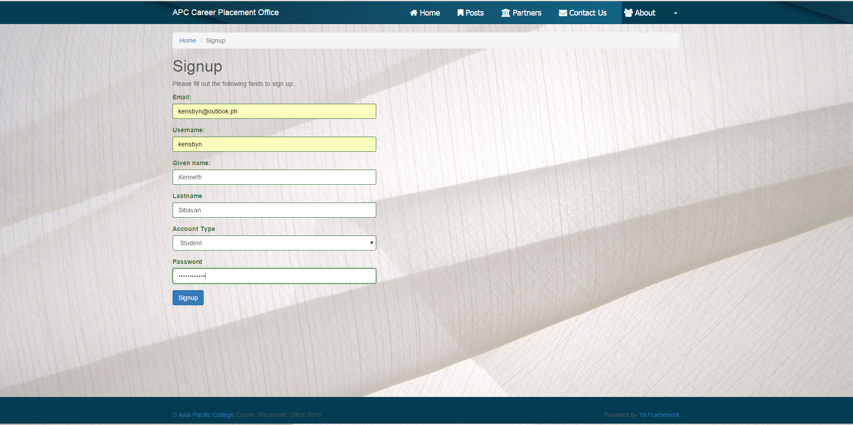

Figure : Signup form with user information

#### Login form

The log-in form provides role-based access to certain features of the website. Here’s how to log in.

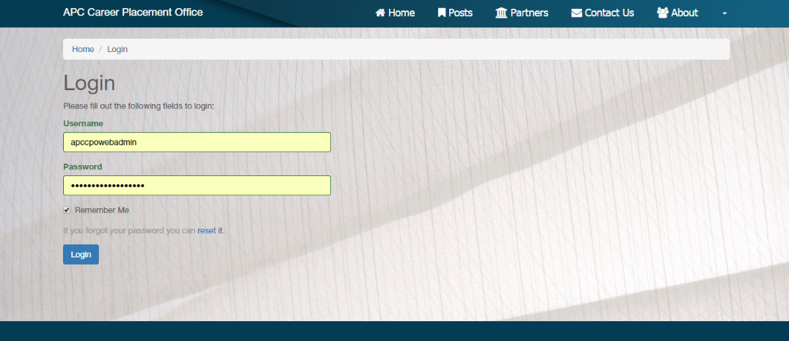

4

3

2

1

Figure 4: Log in page

|  |  |
| --- | --- |
| 1 | Input valid username |
| 2 | Input password |
| 3 | Check/Uncheck to save password |
| 4 | Click ‘Login’ |

#### logging out

Logging out the website is simple. Just click the logout button when you click your username profile.

### HOMEPAGE

The homepage is where the website starts when you first log in to the site. It shows quick links and access to recent posts the CPO announces.

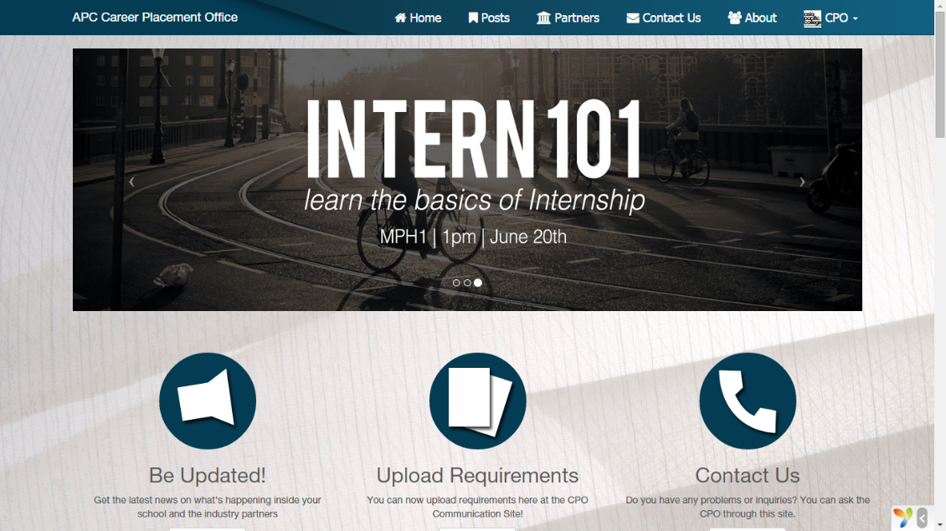

Figure 5: Homepage

#### Slider

The slider is used to provide both students and staff current information using graphics or photos.

#### Quick Links

The quick links acts as direct links to pages most important to an account logged-in. This provides a direct communication and fast interaction between parties.

#### Quick look

Quick look are featured posts or announcements the client wants the students to see firsthand. It provides brief details on a post and places an image to further communicate with.



Figure 6: Quick Look - Featured Post

### Posts

It is the webpage where you can see all the posts listed it shows in detail what the title of the posts is and who authored it.

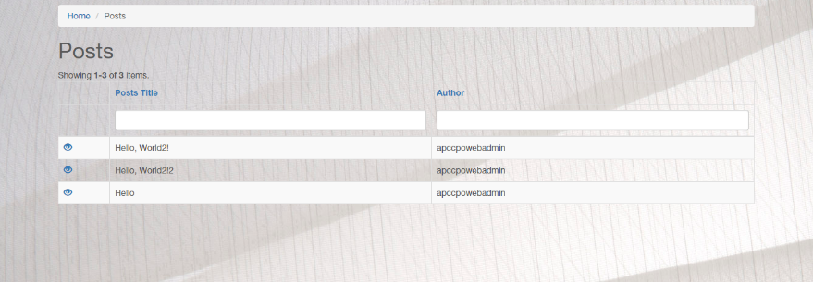

Figure 7: Posts Page

#### individual posts

Individual posts consist of the title, the body, post information and quick links to some of the latest posts.

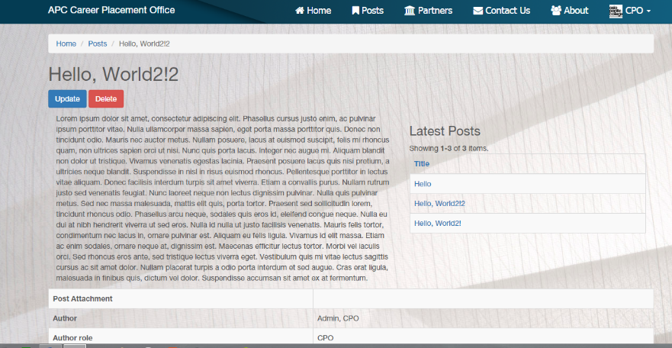

Figure 8: Individual Post Sample

### Industry Partners

The Industry Partners page is a page where all active partners of APC-CPO are listed and provides details about each of them.

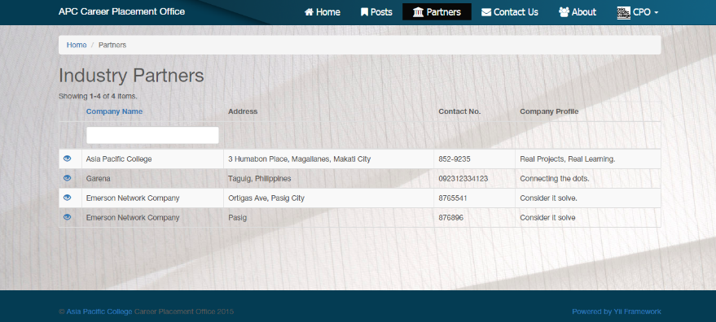

Figure 10: Industry Partners Page

### contact us

This page provides a platform where the account holder can communicate with the client through a mailer form that is automatically linked.

#### submitting an inquiry

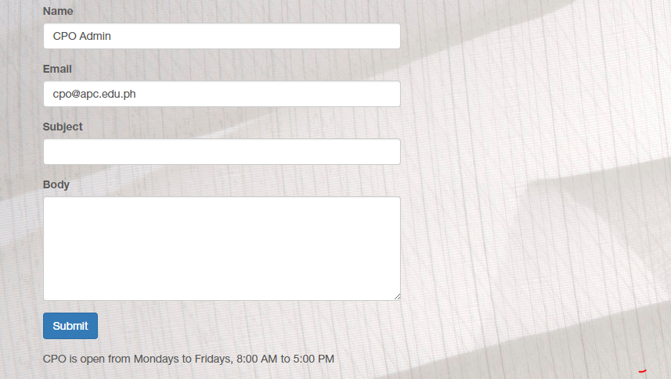

3

2

1

Figure 11: Contact Us Page

|  |  |
| --- | --- |
| 1 | Input the subject of the matter you want to inform |
| 2 | Include the body where you put in detail your concern |
| 3 | Submit it by clicking the button ‘Submit’ |

### About Page

This is the page where you get all information regarding the Career Placement Office and some of the links of its services. It also features the developers of the website.

## BackEnd

### Navbar

The Navbar or Navigation bar is the part of the system where quick links are accessible. The backend’s nav bar is different from the homepage to identify the difference between the two. You can access the backend site if you are a valid admin. Click ‘Manage Website’ to go to the backend page.

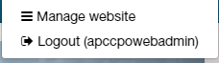

Figure 12: Manage website

### Dashboard

Dashboard is where quick links to important information is seen. It has a shortcut for creating posts as well.

#### Creating a Post

Creating a post/announcement is easy. Here are the steps to follow:



1

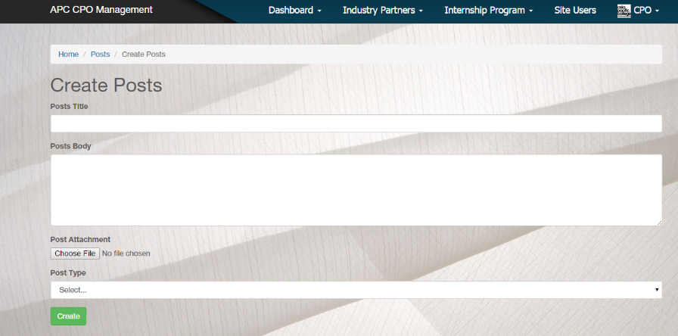

6

5

4

3

2

Figure 13: Creating a post

|  |  |
| --- | --- |
| 1 | Click ‘New Post’ |
| 2 | Include title of the post desired |
| 3 | Include the body of the post |
| 4 | Upload File (optional) |
| 5 | Choose the category of the post that you want to submit |
| 6 | Click ‘Create’ |

### industry partners

This page show both company lists and contact lists the CPO needs to get for consultation and communication.

### Internship Program

Internship Program consists of lists for Internship, Student and Industry Professor’s List

### Site Users

This is where the admin will look at all the registered users of the website.